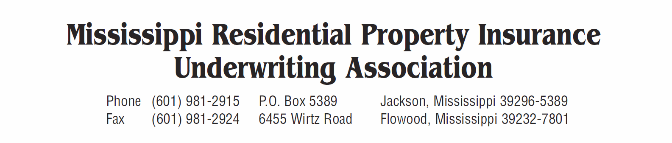

Agent’s Name: _________________________________________________________________

Agent’s Address: _______________________________________________________________

_______________________________________________________________

Authorized Users:

Name: E-mail address:

____________________________________ ____________________________________

____________________________________ ____________________________________

____________________________________ ____________________________________

____________________________________ ____________________________________

____________________________________ ____________________________________

____________________________________ ____________________________________

____________________________________ ____________________________________

____________________________________ ____________________________________

____________________________________ ____________________________________

____________________________________ ____________________________________

____________________________________ ____________________________________

____________________________________ ____________________________________

____________________________________ ____________________________________

____________________________________ ____________________________________

____________________________________ ____________________________________

____________________________________ ____________________________________

